OWENS VALLEY
COPH OHP_279

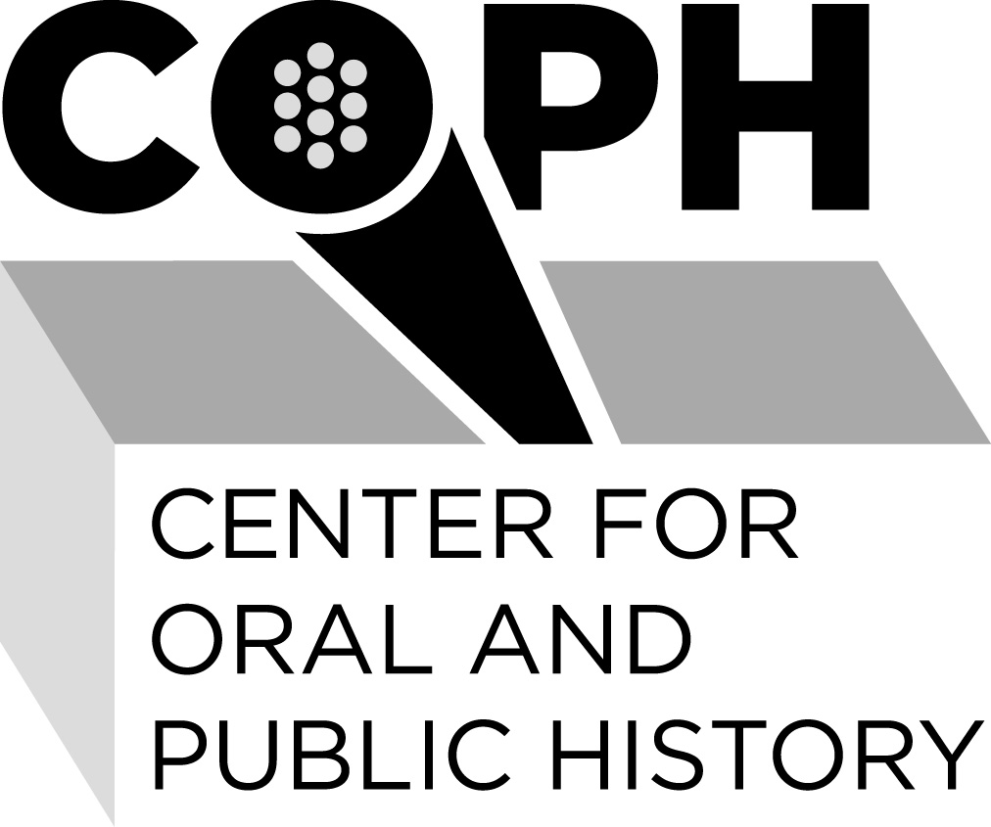

Center for Oral and Public History
California State University, Fullerton

Administrative Information
Acquisition
All items in this collection were donated to the Center for Oral and Public History by the interviewer and interviewees.

Access
The collection is open for research.

Preferred Citation
Citations must identify the oral history number, interviewee, interviewer, date, project, and the Center for Oral and Public History.

Literary Rights and Quotations
The oral histories are made available for research purposes only. No part of the audio tape or the manuscript may be quoted for publication without the written permission of the Center for Oral and Public History, California State University, Fullerton.

Requests for permission to quote from these materials should be addressed to:

Center for Oral and Public History
California State University, Fullerton
P.O. Box 6846
Fullerton, CA 92834

or

coph@fullerton.edu

The request should include identification of the specific passages and identification of the user.

Descriptive Summary

Title
Owens Valley

Date
1976, 1977; Owens Valley Controversy
1995; Women of Bishop

Creator(s)
Ellis Delameter (1976-1977; Owens Valley Controversy)
Nancy Garner (1995; Women of Bishop, California)

Extent
Owens Valley Controversy: Nine (9) oral histories
Women of Bishop: Three (3) oral histories

Collateral:
None

Repository
Center for Oral and Public History
California State University, Fullerton

Project Abstract

OH 1567
Narrator: LARSON, ENID
Interviewer: Delameter, Ellis
Date: 01/09/1977
Project: Owens Valley Water Controversy
Language: English
Location: Big Pine, California
Length: 01:53:43
Audio format: digital
Transcript: verbatim & edited
Abstract
An interview with Enid Larson, resident of Big Pine, California. This interview was conducted on behalf of Cal State Fullerton, for the Environmental Studies Program. Topics include discussion about Larson’s childhood outside Bishop, California, where she was raised on a dairy farm; learning in a one-room schoolhouse; majoring in Zoology at San Jose State, in the late 1920s; post-graduate work in North Carolina; returning to Oroville and Carmel, California to teach high school biology; working at Hastings Natural History Reservation in Carmel (1950s); returning to the Owens Valley in 1969; her early interest in learning the flora and fauna of the Owens Valley and how no research had been done in the past; draining of natural water resources by the Los Angeles Department of Water and Power [DWP]; civil war during the 1920s, in the Owens Valley; working for L.C. Hall (a lawyer) fighting Los Angeles for water rights in the Owens Valley; mentions members of the Watterson family; rivalry and mistrust between banks; Larson’s fight against Cal Trans and highway building; DWP and water pumping in the Valley; towns of Big Pine & Lone Pine vs. Bishop; role of the Department of Fish and Game; the status of wildlife; and finally, the biological makeup of the Valley and it is relevant.

OH 1568
Narrator: DeDECKER, MARY (b. 1909)
Interviewer: Delameter, Ellis
Date: 01/07/1977
Project: Owens Valley Water Controversy
Language: English
Location: Independence, California
Length: 02:05:40
Audio format: digital
Transcript: verbatim & edited
Abstract
An interview with Mary DeDecker, resident of Independence, California. This interview was conducted on behalf of Cal State Fullerton, for the Environmental Studies Program. Topics include discussion about DeDecker’s birth in Oklahoma and childhood in the San Fernando Valley; her husband’s work at the Department of Water and Power [DWP]; their move to Inyo County during the Depression; her interest in flora and becoming an expert on plants of the area; assisting the DWP with an ecological/impact study for their aqueduct; DWP misrepresenting her findings; the effect of water pumping in Inyo County; the roles of the Forest Service and Bureau of Land Management; DeDecker’s work with the League of Women Voters; teaching students about the environment of Owens Valley; lack of building and development in the Valley; weather patterns of the Valley, smog encroachment; and finally, how DWP needs to revise its methods and relationships within the Owens Valley.

OH 1569
Narrator: LYON, AUBREY (b. 1892)
Interviewer: Delameter, Ellis
Date: 11/20/1976
Project: Owens Valley Water Controversy
Language: English
Location: Bishop, California
Length: 01:43:57
Audio format: digital
Transcript: verbatim & edited; 37 pp
Abstract
An interview with Aubrey Lyon, resident of Bishop, California. This interview was conducted on behalf of Cal State Fullerton, for the Environmental Studies Program. Topics include Lyon’s personal background leading up to his arrival in California in 1925; his conservationist involvement; his role as the Planning Commissioner for Inyo County, in the early 1960s; Lyon’s agricultural observations of the Owen’s Valley; his operation of the Rock Creek Lake Resort (1940-1950); the need for a sewage system in Bishop; the Mono Lake Crater Project, designed to transport water from Owens Valley to Los Angeles, for power plant purposes; Lyon’s plea (and failure) to preserve the Owen’s River Gorge; construction of the Pleasant Valley Dam; depletion of pheasant and quail populations; land monopolization and the questions over water rights; exploitation of water by the City of Los Angeles and the Department of Water and Power; Inyo County’s Master Water Plan; how the City of Los Angeles was exempt from the Public Utilities Commission’s regulations; Senate Bill 3191 (Land Exchange Bill), which would have granted City of Los Angeles ownership and administration over all water in the Owens-Mono Basin; Lyon’s discovery that the City of Los Angeles was covertly stealing water from Bishop; the debate over Diaz Lake; and finally, how Lyon believes you cannot put a price on the land or resources of the Owen’s Valley.

OH 1570
Narrator: SMITH, P. DEAN (b. 1924)
Interviewer: Delameter, Ellis
Date: 01/07/1977
Project: Owens Valley Water Controversy
Language: English
Location: Bishop, California
Length: 01:36:48
Audio format: digital
Transcript: verbatim & edited; 26 pp
Abstract
An interview with P. Dean Smith, a farm advisor, and resident of Bishop, California. This interview was conducted on behalf of Cal State Fullerton, for the Environmental Studies Program. Topics include Smith’s personal background; grazing conditions in the Owens Valley; water restrictions placed on the valley by the city of Los Angeles; how the city controls the volume of water going into the Valley; Valley ranchers and their land leases; residents’ attitude toward the city of Los Angeles; Smith involvement in the Environmental Impact Report (EIR) for increased water pumping in the Owens Valley; the future effects of water pumping in the valley; rates of water consumption within the Valley and the city of Los Angeles; how Smith envisions the Valley if DWP and Los Angeles never intervened; the weather factors in the Owens Valley; speculation of unequal representation on the Board of Supervisors; community cohesion of Bishop; and finally, the local suspicions toward the Department of Water and Power.

OH 1571
Narrator: MAIRS, OMIE (b. 1909)
Interviewer: Delameter, Ellis
Date: 01/06/1977
Project: Owens Valley Water Controversy
Language: English
Location: Independence, California
Length: 01:11:28
Audio format: digital
Transcript: verbatim & edited; 27 pp
Abstract
An interview with Omie Mairs, resident of Independence, California. This interview was conducted on behalf of Cal State Fullerton, for the Environmental Studies Program. Topics include Mairs’ personal background, growing up in Independence, and eventually working for the Department of Water and Power (DWP) as an electrician; the early farming in Lone Pine and Manzanar; the incident at the Alabama Gates Spillway; dynamiting of local wells; Mairs’ grandfather’s position on the Board of Appraisers for Inyo County; the water controversy during his high school years; inter-high school sports and competition in the Valley; the process of land checkerboarding; DWP superintendent Ed Leahy; leaving the DWP in 1936; tearing down of homes by the DWP; Mairs as a local businessman and his relationship with the city of Los Angeles; incidents of dynamiting; city of Los Angeles buying up property in the Owens Valley, and their subsequent leasing policies for residents; city of Los Angeles’ water metering process (on Valley residents); the concept of the Owens Valley being a “colony” of Los Angeles; environmental concern of Owens Valley residents; the refilling of Diaz Lake; perspectives of young vs old residents; recent lawsuit of Inyo County v. DWP (to stop underground pumping); how the city of Los Angeles may impede economic growth in the Valley; residential complaints about the city of Los Angeles’ agricultural leasing policy; Los Angeles Times coverage of the Owens Valley water controversy; and finally, the faint possibility of a solution.

OH 1572
Narrator: ABRAMS, JOHN (b. 1894)
Interviewer: Delameter, Ellis
Date: 11/21/1976
Project: Owens Valley Water Controversy
Language: English
Location: Bishop, California
Length: 02:02:19
Audio format: digital
Transcript: verbatim; 37 pp
Abstract
An interview with John Abrams, resident of Bishop, California. This interview was conducted on behalf of Cal State Fullerton, for the Environmental Studies Program. Topics include Abrams’ ancestral, educational, and professional background; his involvement in public land management; fighting Los Angeles lawyers and the acquisition of lands in the Owens Valley; the Raymond Basin (Los Angeles); establishment of the Water Rights Board in Los Angeles; his opinion on the relationship between the Regional Water Quality Control Board and the (Los Angeles) Board of Supervisors; his position on the Bishop Creek Water Association; environmental issues of water well drilling and septic tanks; and the Watkins Plan.

OH 1573
Narrator: WILFRED, PARTRIDGE (b. 1914)
Interviewer: Delameter, Ellis
Date: 01/08/1977
Project: Owens Valley Water Controversy
Language: English
Location: Bishop, California
Length: 00:59:24
Audio format: digital
Transcript: edited; 28 pages
Audio:
An interview with Wilfred Partridge, resident of Bishop, California. This interview was conducted on behalf of Cal State Fullerton, for the Environmental Studies Program. Topics include Partridge’s personal background, born on a ranch in the Owens Valley; his memories of early water conflicts, during the 1920s; incidents of dynamiting; Alabama gates incident; Father John Crowley and tourism in the Owens Valley; the dry years of the 1930s; local ranchers leasing land back from city of Los Angeles; water metering; Diaz Lake incident; what Inyo County would be like if Los Angeles didn’t own most of the land; changes in wildlife and hunting; the current relationship between local Owens Valley residents and the city of Los Angeles; installation of the second aqueduct in the Owens Valley and its toll; thoughts on a solution to the water conflict; the burning of vacant houses in the Valley; Partridge’s father’s position on the Board of Supervisors; and finally, potato farming in the Owens Valley.

OH 1574
Narrator: PARRATT, SYDNEY & CLARA
Interviewer: Delameter, Ellis
Date: 12/08/1976
Project: Owens Valley Water Controversy
Language: English
Location: Laguna Hills, California
Length: 01:20:59
Audio format: digital
Transcript: verbatim; edited; final (14 pp)
Abstract
An interview with Mr. and Mrs. Parratt, residents of Laguna Hills, California. This interview was conducted on behalf of Cal State Fullerton, for the Environmental Studies Program. Topics include Sydney Parratt’s background and occupation as a surveyor for the Department of Water and Power; Clara Parratt’s background as an Inyo County native; Sydney’s relationship with William Mulholland; Clara’s childhood memories in Inyo and the local farming, her father was also the sheriff; Sydney’s memories of arriving in the Owen’s Valley, in the early 1920s; his position as District Engineer of the L.A. Aqueduct Division in 1948, overseeing all water activities in Inyo County; the Alabama Gates incident; relations between the city of Los Angeles and local residents; the buying period of 1929-1931; growth in the Owens Valley; city of Los Angeles leasing land back to residents; Mono Lake; accusations from the city of Los Angeles of water wasting in the Valley; the question of what if the city of Los Angeles never intervened in Inyo County; and the changes in weather and climate.

OH 1575
Narrator: BRIERLY, ARLIE (b. 1884)
Interviewer: Delameter, Ellis
Date: 11/19/1976
Project: Owens Valley Water Controversy
Language: English
Location: Independence, California
Length: 01:13:14
Audio format: digital
Transcript: verbatim; edited
Abstract:
An interview with Arlie A. Brierly, resident of Independence, California. This interview was conducted on behalf of Cal State Fullerton, for the Environmental Studies Program. Topics include Brierly’s birth and upbringing in the town of Bishop; teaching school in Bishop and Independence; sheep and cattle raising in the Owens Valley; early talk of Los Angeles buying up ranch land for water; formation of Associated Ditches and the Owens Valley Protective Association to deal with the city of Los Angeles; formation of the Irrigation District; the heightened tensions of the time, such as residents carrying weapons and dynamiting; Brierly’s ownership in the Bishop Creek Ditch; “checkerboarding” of land by the city of Los Angeles; orchards in the Owens Valley; dynamiting of water wells; Brierly’s job as [Inyo] county assessor; the Watterson brothers and the corruption of the banks; suicide of resident Joe Garner; purchase of land by Rickey Cattle Company; Alabama Gates incident; George Warren; the increase of ground water pumping; Diaz Lake incident; his opinion on land management by the city of Los Angeles; water metering by the city of Los Angeles; the environmental factors in the Valley; Sheriff Collins; and finally, his lifelong career in the Owens Valley.

OH 5277
Narrator: TALBOT, HELEN
Interviewer: Garner, Nancy
Date: 11/10/1995
Project: Women of Bishop
Language: English
Audio format: cassette
Transcript: not transcribed
Abstract
An oral history with Helen Barlow Talbot, a longtime resident of Bishop, California. This interview was conducted for the Women of Bishop area project for California State Fullerton’s Center for Oral and Public History. The purpose of this interview was to gather information about her personal experiences while living in the town of Bishop. Specifically, the interview covers her personal life growing up in Bishop, the chores and schools she attended; talks about the weekend dances at Keough Hot Springs, sheep camp, and clothing styles during the early 1930s; describes behavioral and dating patterns among teenagers during the 1930s; she comments on her change from Mennonite Protestantism to Methodism, college and work history while living in Bishop, and wedding in 1938; discusses her child births and use of birth control contraceptives; explains her experiences of food rationing in Bishop during World War II, and Christmas traditions; describes aging and her attitude towards health; details social activities surrounding her children’s lives, ranch life, the lives of her grandchildren, and feelings towards the Second World War; comments on financial cost changes over the years and how she and her husband dealt with their finances; and the significance of her family’s bond over the years.

OH 5278
Narrator: BOOTH, ALICE
Interviewer: Garner, Nancy
Date: 12/04/1995
Project: Women of Bishop
Language: English
Audio format: cassette
Transcript: not transcribed
Abstract
An oral history with Alice H. Boothe, a longtime resident of Bishop, California. This interview was conducted for the Women of Bishop area project for California State Fullerton’s Center for Oral and Public History. The purpose of this interview was to gather information about her personal experiences while living in the town of Bishop. Specifically, the interview covers her personal life growing up in Big Pine, California, her family, and chores she performed; talks about her high school level of education, expectations bestowed on her by her mother, and close relationships she held with childhood friends; she details her teenage years living in Bishop, high school dances at Keough Hot Springs, dating habits, and extracurricular activities during the 1930s; her experiences during the Great Depression, food and sugar rationing; describes her religious experiences while growing up in the Methodist church; talks about her experiences in high school as a secretary and student; describes her husband, Dudley, her wedding in 1937, and her children and their births starting with her son John; her description of the maternity care she was given, expectations for her children, and her son’s deployment to Vietnam; explains conditions of her daily life during World War II and her family’s business at a local packing station; talks about the length and jobs of her days while living with her family, daily life while living on the ranch and holiday traditions; describes her feelings on the Vietnam war, her parent’s and husband’s deaths, raising horses and cattle, and her grandchildren.

OH 5279
Narrator: CLEMENTS, GENEVIEVE
Interviewer: Garner, Nancy
Date: 12/09/1995
Project: Women of Bishop
Language: English
Audio format: cassette
Transcript: not transcribed
Abstract
An oral history with Genevieve A. Clements, a longtime resident of Bishop, California. This interview was conducted for the Women of Bishop area project for California State Fullerton’s Center for Oral and Public History. The purpose of this interview was to gather information about her personal experiences while living in the town of Bishop, California. Specifically, the interview covers her personal life growing up in Bishop, her family’s daily life, father’s business and how he managed it in Bishop; she talks about her chores, primary school experiences, and love for music during the 1920s; explains her first college experiences while in a sorority at University of California, Berkeley; details her teenage years at Keough Hot Springs on the weekends, swimming, and dancing during the 1930s; describes her college years studying political science and business in Berkeley and San Francisco, her elopement and description of her husband in 1934; talks about her work at her family’s resort on the Arcularius Fish Ranch starting in 1935, her children’s births; explains her experiences during the Great Depression, her involvement with food rationing and lack of jobs; her description of what birth control methods she used; her involvement with the Red Cross during World War II, giving people places to stay, handing out clothes, helping veterans, and fundraisers; talks about her family’s holiday traditions, strict rules, and children’s daily lives during the 1960s; describes her parent’s and husband’s aging and deaths; her changing relationship with the management and care of the resort at the Fish Ranch; details her marriage to her husband over the course of 58 years.

